AGRICULTURAL ECONOMIC POTENTIAL INPUT INTO EIA REPORT

FOR

ONE 400KV DOUBLE CIRCUIT TRANSMISSION POWER LINE FROM THE EXISTING FIRGROVE SUBSTATION TO A PROPOSED NEW SUBSTATION IN MITCHELL’S PLAIN

AND

ONE 400KV SINGLE CIRCUIT TRANSMISSION POWER LINE FROM THE NEW SUBSTATION IN MITCHELL’S PLAIN TO THE EXISTING PHILIPPI SUBSTATION PROPOSED TO BE UPGRADED

May 2011

Compiled By: S G Ferreira

Agricultural Economic Consultants

202 Mimosa Street, Clubview, Centurion 0157, South Africa P O Box 12034, Clubview 0014, South Africa
Tel (012) 654 6005 Fax 086 642 7017
Cell 083 310 4872 E Mail: sgferreira@icon.co.za
Web Page: www.agriconcept.co.za

TABLE OF CONTENTS
Page No

1. Introduction 1
2. Project areas 1
3. Methodology 2
4. Eskom agricultural policy 2
5. Natural resources 3
5.1 Soils 3
5.1.1 Mitchell’s Plain-Philippi 4
5.1.2 Firgrove-Mitchell’s Plain 4
5.1.3 Alternative substations 6
5.2 Topography 7
5.3 Climate 7
5.4 Vegetation 8
5.5 Water 9
5.5.1 Surface water 9
5.5.2 Geo-technical aspects 11
6. Current land use 11
6.1 Break-down of current land-use 11
6.2 Cultivated area 13
6.2.1 Firgrove Mitchell’s Plain project area 13
6.2.2 Mitchell’s Plain Philippi project area 14
6.3 Other 14
7. Financial Implications 15
7.1 Land values 15
7.2 Gross income per ha 15
8. Employment opportunities 15
9. Fatal flaws 15
10. Impact assessment 17
10.1 Affected area 17
10.1.1 Transmission lines 17
10.1.2 Alternative substations 17
10.2 loss in production during construction phase 17
10.3 Permanent loss in production 17
10.4 Long term interference with farming operation 18
10.5 Impact on employment opportunities 18
10.6 Alternative sub stations 18
10.7 Summary Impact Assessment where Transmission Lines Intersect Cultivated Land 18
11. Pylon evaluation 19
12. Conclusion 20
13. References 21

LIST OF TABLES

Table 1 Servitude width, minimum ground clearance as well as minimum safe distance to trees, structures etc. according to voltage 3
Table 2 Soil potential of the Mitchell’s Plain-Philippi route 4
Table 3 Soil potential of the Firgrove-Mitchell’s Plain route 5
Table 4 Climate Data 7
Table 5 Area according to type of vegetation, project areas 8
Table 6 Break-down of land use, project areas 11
Table 7 Labour requirements, vegetable production, Western Cape 15
Table 8 Areas of servitudes according to region 17
Table 9 Summary of ratings from an agricultural economic aspect for all pylons 19

LIST OF FIGURES

Figure 1 Demarcation of project areas 1
Figure 2 Alternative 1 site for substation, Mitchell’s Plain 6
Figure 3 Alternative 2 site for substation, Mitchell’s Plain 6
Figure 4 Vegetation, Firgrove- Mitchell’s Plain Project Area (Source: Steenkamp M. 2010) 8
Figure 5 Vegetation, Mitchell’s Plain-Philippi Project Area (Source: Steenkamp M. 2010) 9
Figure 6 Distribution of surface dams, Firgrove Mitchell’s Plain project area (Source: Steenkamp M. 2010) 10
Figure 7 Distribution of surface dams, Mitchell’s Plain Philippi project area (Source: Steenkamp M. 2010) 10
Figure 8 Land use Firgrove Mitchell’s Plain project area (Source: Steenkamp M. 2010) 12
Figure 9 Land-use, Mitchell’s Plain –Phillipi, Project Area (Source: Steenkamp M. 2010) 12

Introduction
BKS has been appointed by Eskom Holdings Limited to execute an Environment Impact analyses (EIA) for the following proposed developments:
- One 400kV double circuit Transmission power line of approximately 23km from the existing Firgrove substation to a proposed new substation in Mitchell’s Plain; and
- One 400kV single circuit Transmission power line of approximately 7km from the same proposed new substation in Mitchell’s Plain indicated above to the existing Philippi substation proposed to be upgraded.
- Mitchell’s Plain Substation and Mitchell’s Plain-Firgrove 400kV power line

Agriconcept (Pty) Ltd has been appointed by BKS to execute a study to determine the loss of agricultural potential as a result of above mentioned developments.

One consolidated report is presented for both the projects in such a manner that that a clear distinction is being made between the projects.

Project areas
The combined project areas for the three projects are demarcated in Figure 1.

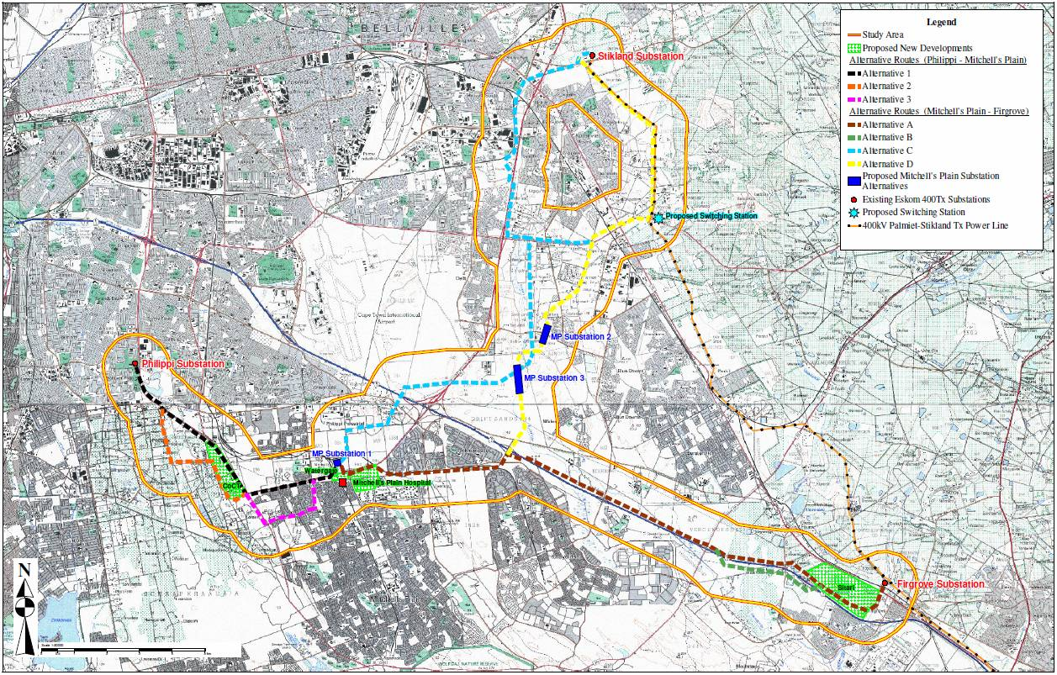
Figure 1 Demarcation of project areas

Methodology
The land cover has been analysed for both the project areas and includes areas occupied by town development, agriculture, natural bush etc. Agriconcept made use of BKS GIS Division to do the analyses. .Enpat environmental data base was used for this purpose.

Other information such as vegetation, soil potential etc, as included in Enpat was analysed and included in the report. Images from Google Earth (12 February 2009) were applied to control Enpat data and adjustments were made if necessary.

Soil potential was obtained from the Agricultural Research Council (ARC) Institute for Soil, Climate and Water.

Groundwater information was obtained from the Department of Water Affairs (DWA). The information covers a wide area and is not specifically applicable to the project areas. Farmers in the project area were also contacted to control this information. This information may be more applicable than those of DWA.

Land owners in the project areas were contacted to confirm cropping programmes, yields, water sources etc.

Eskom agricultural policy
It appears that Eskom does not have a policy regarding the exercising of agricultural activities as such under electric transmission lines. They, however, do have policy guidelines regarding vegetation management in the vicinity of transmission lines (Vosloo 2009). Elements of these guidelines are applicable on agricultural activities.

Eskom will register servitude on private property if transmission lines intersect these properties.

The definition for Eskom servitude is as follows: It is the right to use someone else’s land, for a specified purpose. In the case of overhead line servitude, it is the right to erect, operate and maintain an electric line as well as enter that land for the execution of those activities. It does not constitute full ownership of land. Access and activities should always be carried out with due respect for the landowner. Servitude is registered in the Deeds office and forms part of the title deed of a property.

Eskom also has the right to enter the servitude area to maintain the transmission lines.

The main reasons for managing the vegetation under power lines are:
- Ensuring safe clearances under and around power lines.
- Ensuring adequate access for inspection, maintenance and repair activities
- Reduction of fuels for fires under power lines that cause flashovers.

It is known that Eskom allows agricultural activities to be exercised within the servitude area of power lines as long as the agricultural crops and equipment do not interfere with the power lines.

The minimum ground clearance as well as minimum safe distance to trees, structures etc. according to voltage are shown in Table 1.

Table 1 Servitude width, minimum ground clearance as well as minimum safe distance to trees, structures etc. according to voltage
Voltage (kV) | Servitude width (m) | Ground clearance (m) | Safe distance to trees (m)
132 | 31 to 36 | 6,3 | 3,8
220 | 47 | 6,7 | 4,2
275 | 47 | 7,2 | 4,7
400 | 47 to 55 | 8,1 | 5,6
533 DC | 30 | 8,6 | 6,1
765 | 80 | 10,4 | 8,5
Source: Vosloo, 2009

Although it could not be confirmed, it is doubtful if Escom will allow overhead irrigation under transmission lines. It would not be possible to do pivot irrigation if the transmission line intersects the pivot circle. It is possible that drip and micro irrigation can be exercised under transmission lines but Eskom needs to confirm it.

The servitude width required to accommodate the towers on which the Transmission power line will be strung varies from 35m to 55m wide, depending on the type of pylon tower required. The servitude is required in order to ensure safe construction, maintenance and operation of the Transmission power line and Eskom will be entitled to unrestricted access.

Depending on route alignment, Eskom may require access/service roads for the construction and maintenance phases.

Natural resources

Soils
The Agricultural Research Council, Institute for Soil, Climate and Water (ARC-ISCW) executed a study to determine soil potential in the study area.

A desk study was executed to determine soil potential. Most of the study area occurs within the boundary of the coverage by 1:50 000 scale soil maps (Jacobs, Oosthuizen & Stehr, 2003). It was therefore decided to use this information. In the 1:50 000 scale survey, soil mapping units were established according to dominant and sub-dominant soil forms, which could then be allocated to a class of general agricultural potential.

Mitchell’s Plain-Philippi
The area consists mainly of moderately deep to deep, fine- to medium-grained, grey to yellow sandy soils, dominantly of the Fernwood (Fw) and Namib (Nb) soil forms. Where the sandy soil has a subsoil clay horizon (“duplex” soil character), these soils belong mainly to the Kroonstad (Kd) and Katspruit (Ka) soil forms. Smaller areas of shallow soils with a structured clay or hardpan carbonate subsoil also occur. A summary of the main soil characteristics is given in Table 2.

Table 2 Soil potential of the Mitchell’s Plain-Philippi route
Map Unit | Dominant Soil form | Agricultural Potential
dNb | Namib | Low to moderate
dFw | Fernwood | Low to moderate
dLt | Lamotte | Low to moderate
mdLt | Namib | Low to moderate
sKd | Kroonstad | Low
sKa | Katspruit | Very low
dWb | Witbank | Very low
U | - | None
Source: Paterson 2010

The corresponding colours as shown on the soil map

Firgrove-Mitchell’s Plain
The area consists mainly of a mixture of soils. Moderately deep to deep, fine- to medium-grained, grey to yellow sandy soils, dominantly of the Namib (Nb) soil form, occur mainly in the west, while shallower, duplex soils (sandy topsoil abruptly overlying a structured clay subsoil) of the Kroonstad (Kd) or Estcourt (Es) soil forms are found more toward the east. An area of wetland soils of the Katspruit (Ka) soil form is found next to the Kuils River, just east of Khayelitsha and the Eerste River itself.

Table 3 Soil potential of the Firgrove-Mitchell’s Plain route
Map Unit | Dominant Soil form | Agricultural Potential
dNb | Namib | Low to moderate
dHu | Hutton | Moderate to high
mdNb | Namib | Low to moderate
mdKd | Kroonstad | Low to moderate
sNb | Namib | Low
sGs | Glenrosa | Low
sKd | Kroonstad | Low
sKa | Katspruit | Very low
vsKa | Katspruit | Very low
Vlei | Katspruit | None
U | - | None
Source: Paterson 2010

Alternative substations
There are three alternative substations on the Firgrove-Mitchell’s Plain transmission line.
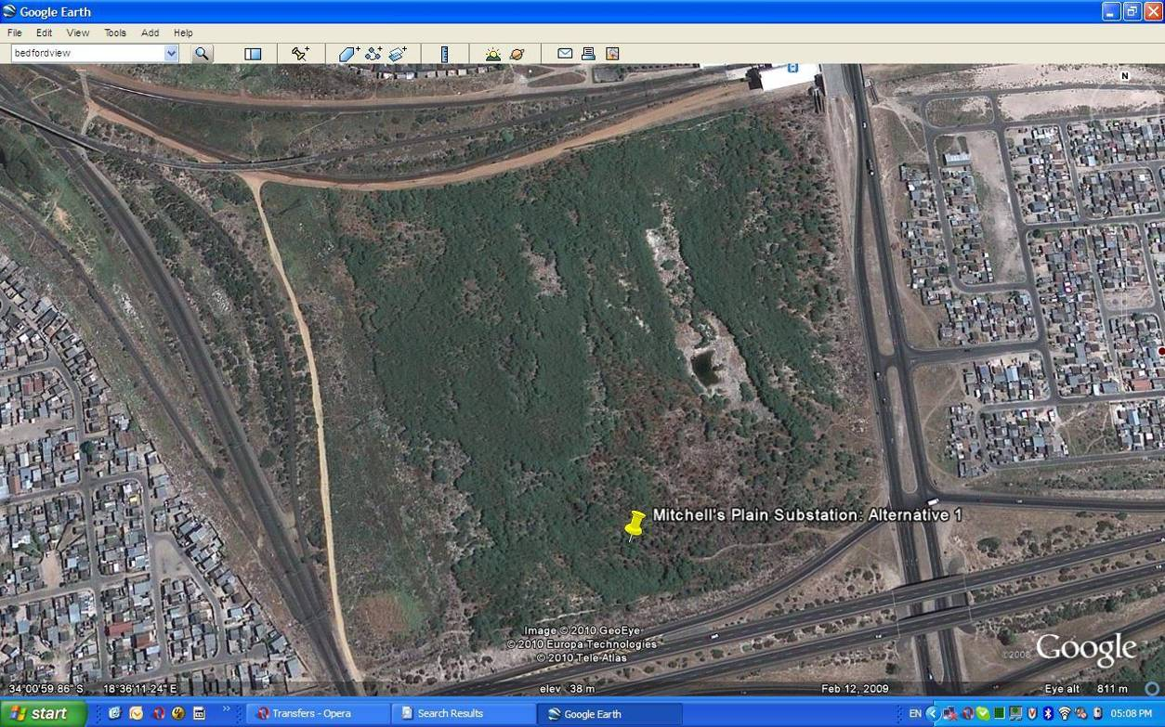
Figure 2 Alternative 1 site for substation, Mitchell’s Plain

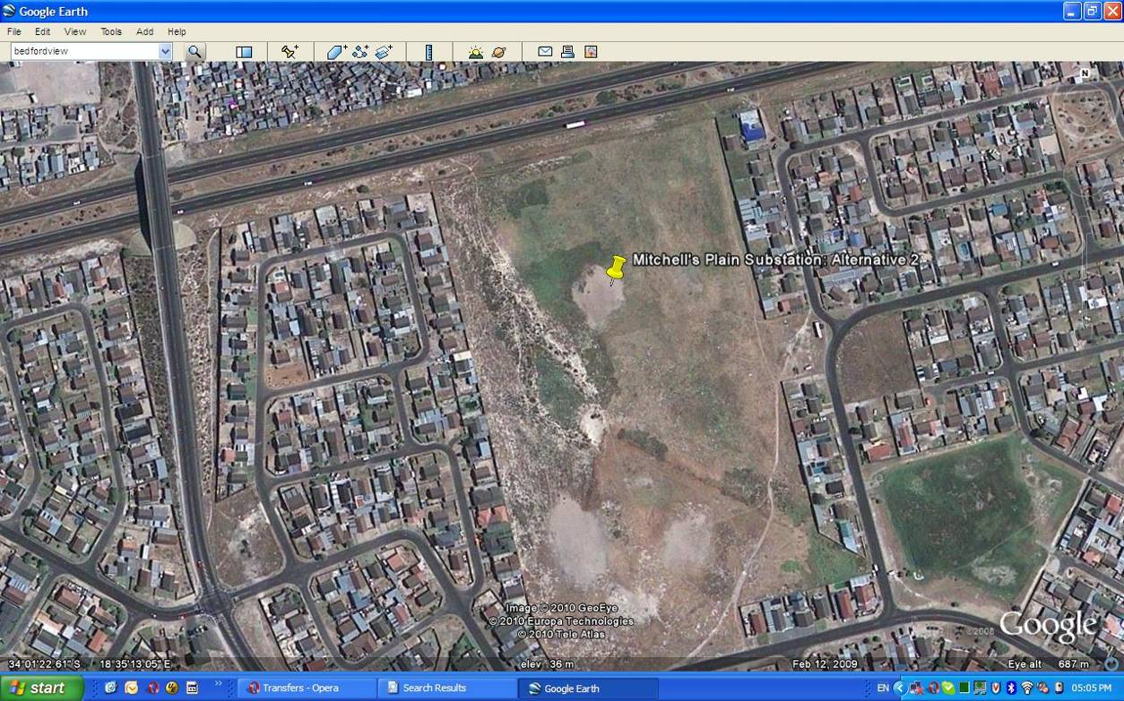
Figure 3 Alternative 2 site for substation, Mitchell’s Plain

Alternative 1 and 2 sites are surrounded by residential areas.

The soils on Alternative sites 1 and 3 for the proposed substation are predominately sandy soils (deep Fernwood/Namib) and have a low to moderate agricultural potential, with restrictions caused by the low inherent fertility and the excessive drainage from the sandy texture. The soil at Alternative site 2 is close to a wetland and has a subsurface clay horizon in the soil profile. The soil also has a low agricultural potential. From a grazing viewpoint all these sites have also a low potential. The impact of the potential loss of these soils from an agricultural view point is very low, due to both the soil characteristics as well as the urban nature of the immediate surroundings. (Paterson, D. G. May 2010)

Topography
The area is located on the Cape Flats. The area is mostly flat with an elevation of approximately 40 meters above sea level.

Climate
The climate of the area can be regarded as typical of the Cape West Coast, with a low, all-year round rainfall distribution, warm to hot summers and cool winters. The main climatic indicators are shown in Table 4.

Table 4 Climate Data
Month | Rainfall (mm) | Min. Temp (ºC) | Max. Temp (ºC)
Jan | 14.5 | 15.5 | 29.5
Feb | 14.7 | 15.6 | 29.8
Mar | 13.8 | 14.4 | 28.4
Apr | 48.9 | 11.9 | 25.3
May | 76.7 | 9.2 | 21.5
Jun | 89.2 | 6.9 | 18.4
Jul | 89.0 | 5.7 | 17.6
Aug | 79.9 | 5.9 | 18.4
Sep | 45.9 | 7.4 | 20.3
Oct | 32.7 | 9.4 | 23.3
Nov | 21.7 | 12.4 | 26.3
Dec | 14.8 | 14.3 | 28.2
Year | 524.7 mm | 17.3ºC (Average)
Source: (Paterson, D. G. May 2010)

The extreme high temperature that has been recorded is 43.0oC (presumably in “berg wind” conditions) and the extreme low –0.5ºC.

Vegetation
According to Mucina and Rutherford (2006) veld types of the area are being classified as Cape Flats Dune Strandveld, Cape Flats Sand Fynbos, Swartland Shale Renosterveld and the Cape Lowland Freshwater Wetlands. The area according to veld type is shown in Table 5.

Table 5 Area according to type of vegetation, project areas
Item | Mitchell’s Plain – Firgrove (Ha) | Mitchell’s Plain – Philippi (Ha) | Mitchell’s Plain – Stikland (Ha)
Cape Flat Dunes | 2 578,8 | 1 551,5 | 4 435,2
Cape Low Land Fresh Water Wetlands | 225,8 |  | 73,3
Cape Flats Sand Fynbos | 1 041,8 | 897,7 | 3 457,1
Swartland Schale: Renosterveld | 332,7 |  | 36,7
Swartland Schale:Granite Renosterveld |  |  | 58,0
TOTAL | 4 179,1 | 2 449,2
Source: (Steenkamp M. 2010)

The original vegetation distribution for the project areas is shown in Figure 4 through Figure 5.

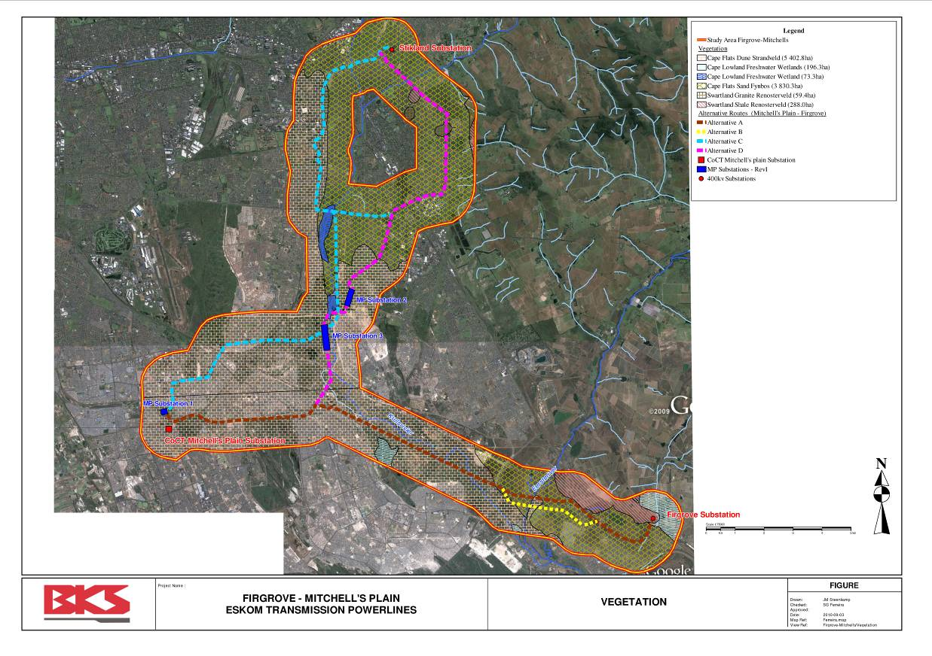
Figure 4 Vegetation, Firgrove- Mitchell’s Plain Project Area (Source: Steenkamp M. 2010)

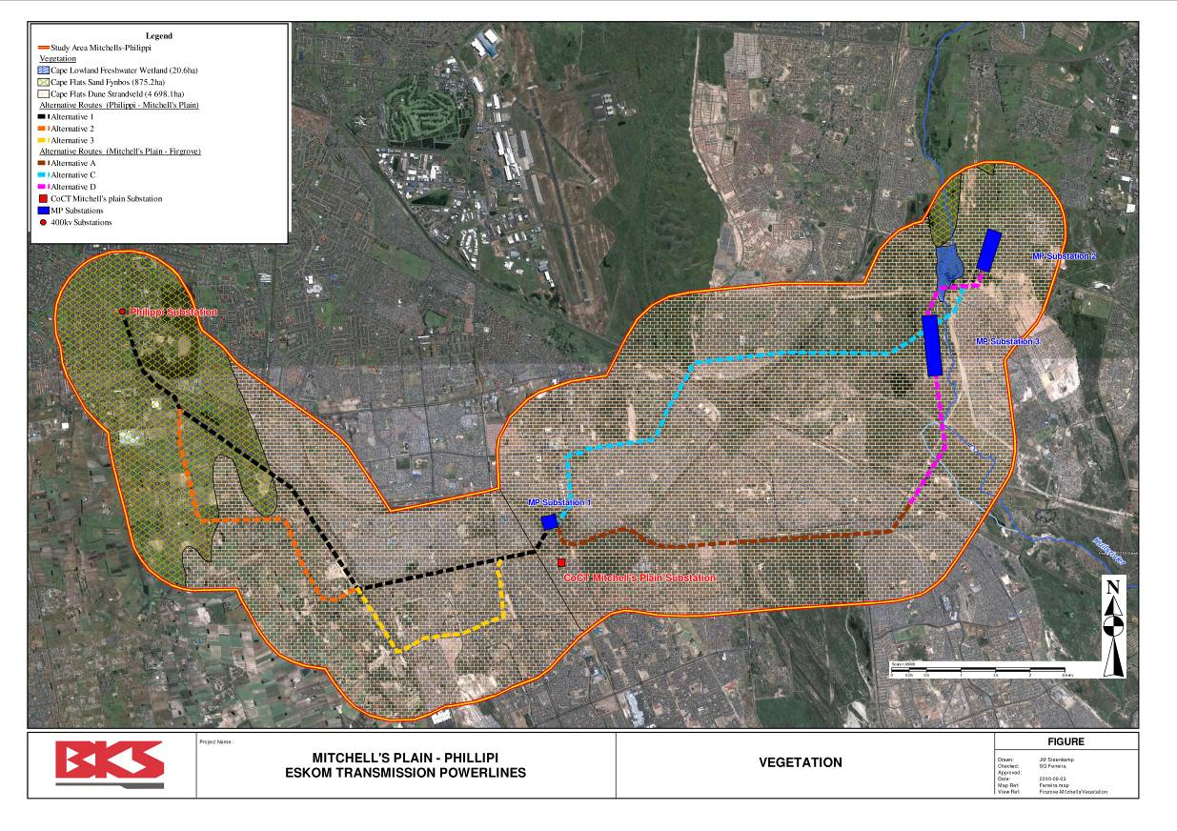
Figure 5 Vegetation, Mitchell’s Plain-Philippi Project Area (Source: Steenkamp M. 2010)

The project areas are very disturbed with patches of natural vegetation remaining. Most of these patches are highly impacted on and the only areas of concern are the Driftsands nature reserve and the Buffelsvlei, which is a large wetland between Firgrove and Mitchell’s Plain. (Le Roux, Betsie.2010)

Detail regarding vegetation in the project areas can be found in the ecological assessment section of the overall report.

It is concluded that the grazing potential of natural grazing is very low due to the absence of large area natural grazing.

Water

Surface water
Surface dams are present on both the project areas. No information is available in this respect but the distribution of these dams is shown in Figure 6 and Figure 7.

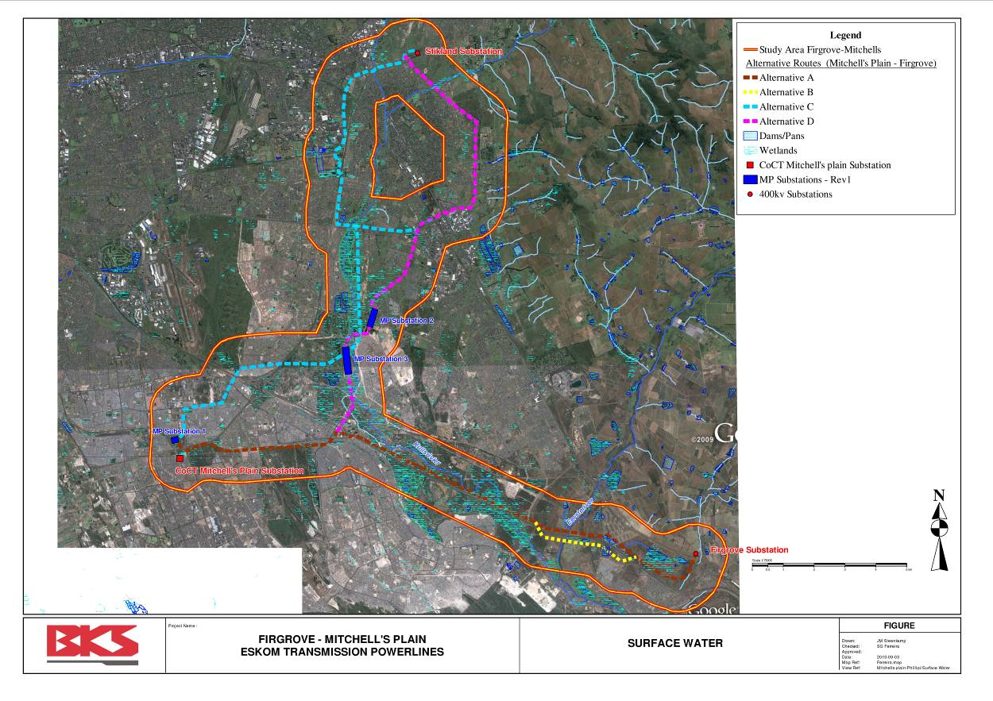
Figure 6 Distribution of surface dams, Firgrove Mitchell’s Plain project area (Source: Steenkamp M. 2010)

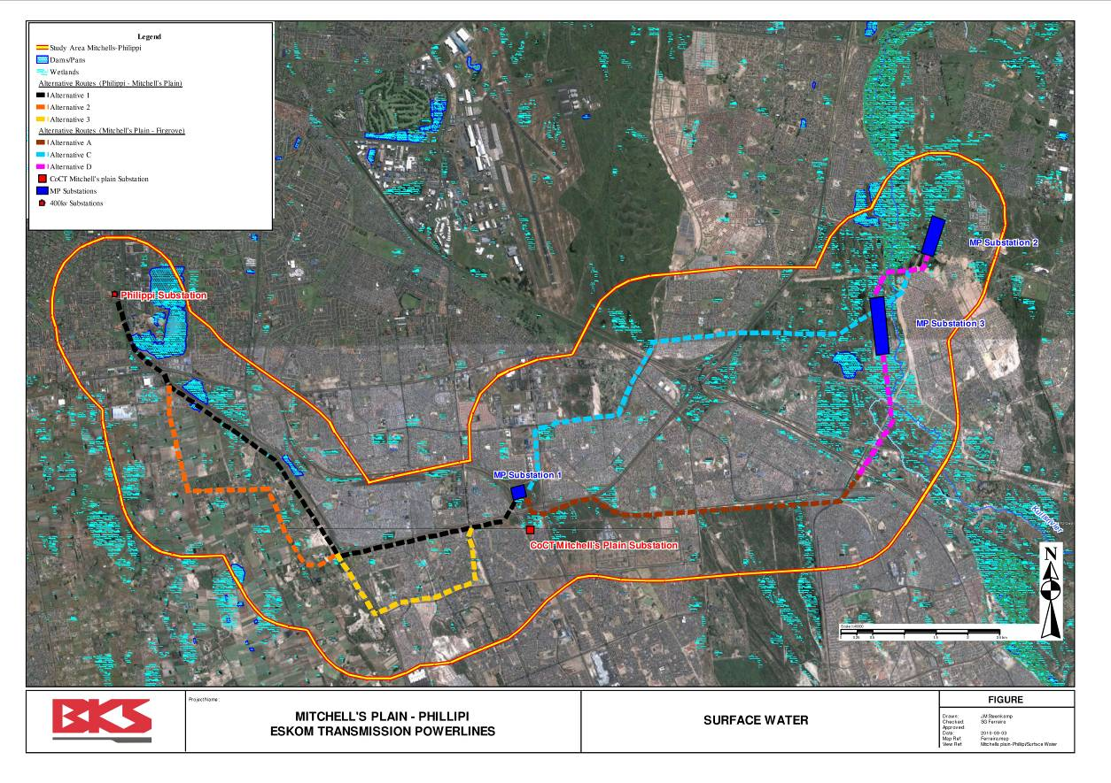
Figure 7 Distribution of surface dams, Mitchell’s Plain Philippi project area (Source: Steenkamp M. 2010)

Geo-technical aspects
Groundwater is applied for irrigation purposes in the Mitchell’s Plain Philippi project area. Water is subtracted from boreholes and pumped into earthen dams which may be lined out with chemical compounds to prevent seepage. Borehole yields are reported to vary between 3,7 and 25 l per second. Borehole depth may vary between 30 and 40 meter. (Rix, Leon, May 2010}.
Quality of water in the region according to the respondents is generally good for irrigation purposes.

Detail regarding geo-technical aspects in the project areas can be found in the geo-technical assessment section of the overall report.

Current land use

Break-down of current land-use
A break-down of current land-use in the project areas is shown in Table 6.

Table 6 Break-down of land use, project areas
Item | Firgrove – Mitchell’s Plain (Ha) | Mitchell’s Plain – Philippi (Ha) | Mitchell’s Plain – Stikland (Ha) | TOTAL (Ha)
Vergenoegd Wine Estate | 225,7 |  |  | 225.7
Cultivated Land | 482,0 | 770,9 | 139,9 | 1 391,8
Forestry | 28,9 |  |  | 28,9
Residential | 1 558,1 | 1 454,5 | 5 622,1 | 8 634,7
Denel Property | 176,5 |  |  | 176,5
Commercial/Industrial |  |  | 203.7 | 203,7
Vacant/Unspecified | 1 707,3 | 219,5 | 2 094,9 | 4 021,7
TOTAL | 4 178,5 | 2 444,9 | 8 059,6 | 14 683
Source: (Steenkamp M. 2010)

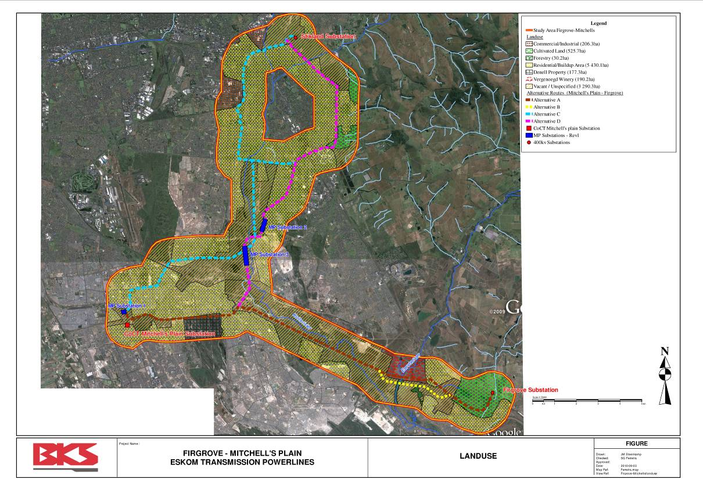
Figure 8 Land use Firgrove Mitchell’s Plain project area (Source: Steenkamp M. 2010)

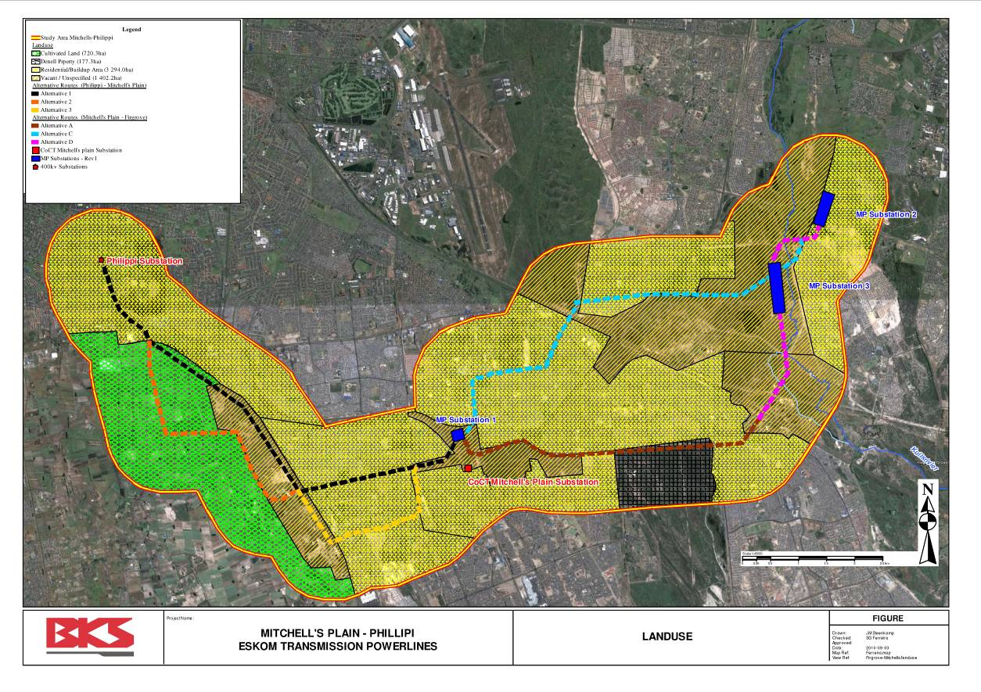
Figure 9 Land-use, Mitchell’s Plain –Phillipi, Project Area (Source: Steenkamp M. 2010)

Cultivated area

Firgrove Mitchell’s Plain project area

Area close to Firgrove Substation
Cultivated land in the Firgrove-Mitchell’s Plain project area extends over 482 ha.
Contradictory information is found with respect to crops produced in the area close to Firgrove Substation. It, however, appears that vineyards and vegetables are found here.

Alternative A transmission line intersect this area.

Vergenoegd Wine Estate
Vergenoegd farm has been owned by the Faure family for six generations. Historic Vergenoegd, was granted land rights in 1696 and the Faures have been on the farm since the 1820’s. The Cape Dutch homestead is a historic monument and dates from 1773.

The following wine cultivars are produced on the estate: Cabernet Sauvignon, Shiraz, Merlot, Cabernet Franc, Malbec, Petit Verdot, Tinta Barocca, Touriga Naçional and other.

An old world cellar, equipped with modern winemaking machinery, is in operation on the estate. (Vergenoegd Estate Winery Web Page, May 2010).

The estate extents over an area of approximately 230 ha. Currently 74 ha are established with vineyards of which 17 ha is irrigated on a permanent basis with drip irrigation system. The remaining vineyards are produced with supplementary irrigation.

The Eerste River intersects the property from north to south.

The main activities on the estate are exercised on the western side of the Eerste River. The eastern side is not cultivated due to poor soils and is currently used for natural grazing. .

Irrigation water is conveyed by a canal upstream in the Eerste River to a lined dam on the property from where vineyards are irrigated. If necessary water is subtracted directly from the Eerste River on the property. This water subtraction is controlled by the Lower Eerste River Irrigation Board.

The quality of the water is threatened by municipal sewage upstream. Contamination is currently at acceptable levels and does not have a negative affect on agricultural production. (Jacobs, Marlize, May 2010)

The alternative routes for transmission lines are as follows:
- Alternative A intersects the vineyards from east to west
- Alternative B intersects the property south of the current vineyards

Several concerns were raised by the current owner Mr. D E Faure by means of E Mails regarding alternative routes affecting Vergenoegd Wine Estate. The main comments are as follows:

Comment 1: Strongly object to alternative 1 across Vergenoegd. Alternative 2 which follows an existing line is far more suitable (although this also crosses our property).

Comment 2: Alternative A (to the north of the N2) over the farm Vergenoegd is not supported due to the impact on the farm in terms of existing farming activities and proposed future development options which are currently being investigated and pursued.

Comment 3: Alternative B (to the south of the N2) also over the farm Vergenoegd is however preferred and supported. This would follow two existing power line corridors and would have significantly less impact on existing and proposed development options. The unsightly lines would also be further away from the historical homestead.

Mitchell’s Plain Philippi project area
Cultivated land in the Mitchell’s Plain Philippi project area extends over 771 ha. The area was originally divided in small holdings of approximately 10 ha each. Commercial irrigated farming is mainly found in this area. Farmers farm on 4 to 5 small holdings which may vary in size from 40 to 50 ha. A variety of vegetables are produced under irrigation. Flower production and small dairies are also present but of minor importance. The following vegetables are produced: Soup vegetables during winter, potatoes, cabbage, cauliflower, salad and other. Double cropping of more than 200 percent is achieved especially when crops with a short growing season such as salad are produced. Sprinkler irrigation systems are mainly found in the area. (Rix, Leon, May 2010).

Other
Natural forest and shrubs of 29 ha are found in the Firgrove -Mitchell’s Plain project area.

Residential or build-up areas extends over 1 558 ha in the Firgrove -Mitchell’s Plain project area and 1 455 ha in the Mitchell’s Plain Philippi project area.

Denel (Pty) Limited, manufacturer of defense equipment in South Africa, owes 177 ha in the Firgrove-Mitchell’s Plain project area.

Vacant and unspecified land covers an area of 1 707 ha in the Firgrove -Mitchell’s Plain project area and 220 ha in the Mitchell’s Plain Philippi project area.

Financial Implications

Land values
Land values are negated by a number of factors such as on-farm infrastructure, soil quality, water availability for irrigation, quality of water, location etc. According to information agricultural land values in the Western Cape has exploded recently. It is only possible to submit a range of values for the purpose of this report.

The market price for vineyards may vary from R400 000 to R1 million per ha while the value of land currently used for vegetable production may vary between R250 000 to R500 000 per ha. The price in the Philippi area is relative high due to the demand of land for industrial development.

An investigation is required to determine more accurate indications.

Gross income per ha
The gross income for vineyards according to industry standards is approximately R30 000 per ha. This is however not applicable to wine estates like Vergenoegd as the total operation is vertically integrated with resultant higher income per ha. This figure is unfortunately not available and can only obtain from the owner if required.

The gross income per ha for vegetable production is substantially higher. The gross income for cabbage could be in the vicinity of R60 000 per ha.

Employment opportunities
The total labour requirements for vegetable production is shown in Table 7.

Table 7 Labour requirements, vegetable production, Western Cape
Type | Man days per ha | Man years per ha
Permanent | 210 | 0,9
Seasonal | 90 | 0,4
TOTAL | 300 | 1,3

One ha of vegetables create approximately 1, 3 employment opportunities.

The total labour requirements for vineyard production, excluding labour requirements in cellar is approximately 150 man days per ha or 0,65 employment opportunities per ha.

Fatal flaws
Fatal flaws are defined as environmental problems that are impossible or prohibitively expensive to manage and that may render the project unacceptable from an agricultural economic perspective.

No serious fatal flaws from an agricultural viewpoint are identified.

The proposed power lines will interfere with crop production but it can be rectified by means of mitigation measures.

Vergenoegd Wine Estate is of aesthetical importance as it is an historical farm and historical monuments are present on the property. It is also an important tourist attraction. The presence of power lines, intersecting the estate may detract the aesthetical value of the estate.

The agricultural potential of the alternative substation is very low.

Impact assessment

Affected area

Transmission lines
Depending on route alignment, Eskom may require access/service roads for the maintenance phases.
The width of servitude areas may vary from 55 m for self supporting structures to 35 m for monopole structures.
The total servitude areas where lines intersect cultivated lines are shown in Table 8.

Table 8 Areas of servitudes according to region
Region | Estimated Distance (km) | Min servitude area (ha) | Max servitude area (ha)
Area close to Firgrove substation (Alternative A) | 2.4 | 8.4 ha | 13 ha
Vergenoegd (Alternative A) | 1,8 | 6,3 ha | 9,9 ha
Mitchell’s Plain Philippi (Alt 1) | 1,4 | 4,9 ha | 7,7 ha
Mitchell’s Plain Philippi (Alt 2) | 3,0 | 10,5 ha | 16,5 ha

Alternative substations
Each of the three alternative substations is approximately 12 ha in extent.

loss in production during construction phase
During the construction phase activities will interfere with the daily farming operations in areas where power lines intersect cultivated land such as Vergenoegd and other irrigation farming. Existing crops will be removed and land owners need to be compensated for loss in production. This compensation will be additional to compensation for servitude rights. It is difficult to give an indication for loss in production as it will be determined by the type of crop as well as stage of development. Compensation for loss in production will increase as harvesting dates are approached.

The impact is of a short term nature for annual and long term crops during construction phase. Mitigation measures will involve the assessment of loss in production and the owner should be compensated accordingly.

The gross income per crop type as explained in section 7.2 serves as indication only regarding maximum crop losses.

Permanent loss in production
Eskom may require access/service roads for the maintenance phases which will imply the removal of long term crops as well as seizing production of annual crops on service roads. With regard to long term crops such as vineyards as well as annual crops, the owners should also be compensated for a loss in long term income where vineyards are removed. This should be included in the servitude value. The value of land as explained in section 7.1 serves as an indication only of servitude values. Vineyards may have a productive life in excess of 20 years.

Long term interference with farming operation
Although maintenance will not be executed regularly at short intervals it will have a long-term impact on farming operations with intensive crop production. Eskom may enter the property in future to execute maintenance. Access and activities should always be carried out with due respect for the landowner. The presence of vehicles and workers during maintenance may interfere with farming operations such as crop spraying. This will be more annoying than anything else. The impact is however low. The servitude amount will also provide for future inconveniences.

Impact on employment opportunities
The construction of lines will not lead to loss of permanent employment opportunities on agricultural land. It may have an impact on temporarily labour but the impact will be low. No mitigation measures are foreseen.

Alternative sub stations
Due to the low agricultural potential of the alternative substation sites, the construction of sub stations will have no impact on agricultural activities in the project area.

Summary Impact Assessment where Transmission Lines Intersect Cultivated Land
Impacts | Duration | Intensity | Probability | Mitigation | Significance After mitigation
TRANSMISSION LINES
Loss in production | Short term | Medium | Highly likely | Compensation crop loss | Low
Loss in production | Long term | Medium | Highly likely | Compensation in servitude value | Low
Long term interference farming operation | Long term | Low | Likely | Compensation in servitude value | Low
Loss employment opportunity | Short and long term | Low | Unlikely | Nothing | Low
SUBSTATION
 |  | Nothing | Improbable | Nothing | No Impact

Pylon evaluation
During a workshop held at BKS head office in Pretoria in March 2011, each pylon position were analysed in terms of agricultural economic impact.
The rating that was used for the purpose of agricultural economic impact is as follows:
0 = no impact
1 = low impact
2 = medium impact
3= high impact
The ratings for each route are summarized in Table 9.

Table 9 Summary of ratings from an agricultural economic aspect for all pylons
Rating | 0 | 1 | 2 | TOTAL
Alternative Routes | Number of pylons
PHILIPPI – MITCHELL’S PLAIN
Alternative 1 | 24 | 10 | 3 | 37
Alternative 2 | 0 | 0 | 15 | 15
Alternative 3 | 14 | 0 | 0 | 14
Alternative 4 | 0 | 0 | 5 | 5
FIRGROVE – MITCHELL’S PLAIN
Alternative A | 46 | 13 | 2 | 61
MITCHELL’S PLAIN SUBSTATION | 3 | 0 | 0 | 3
MITCHELL’S PLAIN – STIKLAND
Alternative C | 39 | 0 | 0 | 39
Alternative D | 75 | 3 | 2 | 80

Conclusion
Based on the ratings of each of the pylons, the following conclusions were drawn:

- PHILIPPI – MITCHELL’S PLAIN
  - Alternative 1 Only 10 pylons have a low impact and 3 a medium impact. The remaining pylons have no impact.
  - Alternative 2 All the sites are rated medium as the line intersects agricultural holdings.
  - Alternative 3 All the sites have no impact.
  - Alternative 4 All the sites are rated medium as the line intersects agricultural holdings.
- FIRGROVE – MITCHELL’S PLAIN
  - Alternative A Most of the sites have low or no impact.
- MITCHELL’S PLAIN SUB STATION
  - All the sites have no impact.
- MITCHELL’S PLAIN – STIKLAND
  - Alternative C All the sites have no impact.
  - Alternative D Most of the sites have no impact.

Therefore, Alternatives 1, 3, A, C and D have a low to no impact with respect to agricultural economic aspects, while alternatives 2 and 4 have a medium impact.

References
JACOBS, MARLIZE, May 2010. Vineyard manager: Vergenoegd Wine Estate. Telephonic communication

LE ROUX, BETSIE. (betsielr@bks.co.za) 2010. Vegetation F-MP-P 400kV Tx p/l: Vegetation. [E-mail to: Ferreira S G]. (sgferreira@icon.co.za), 05.05.2010.

LE ROUX, JOS. August 2010. Executive Director: VinPro. Telephonic communication.

MEYER, P. S. May 2001. An Explanation of the 1: 500 000 General Hydrological Map, Cape Town 3317. Department of Water Affairs and Forestry:

MUCINA, L & RUTHERFORD, M.C. (EDS.) 2006. The vegetation of South Africa, Lesotho and Swaziland. Strelitzia 19. South African Biodiversity Institute, Pretoria.

RIX, LEON, May 2010. Farmer Philippi, Chairman Cape Flats Farming Association. Telephonic communication.

PATERSON, D. G. May 2010. Philippi-Mitchell’s Plain and Mitchell’s Plain-Firgrove transmission line routes, Western Cape. Report Number GW/A/2010/xx. ARC-Institute for Soil, Climate and Water GW/A/2010/xx

SEPTEMBER, W, MAY 2010. Agriculturist, Cape Metro. Telephonic communication.

SCHOEMAN, J.L., VAN DER WALT, M. K. MONNIK, K.A., THACKRAH, A. . . MALHERBE J. LE ROUX R.E. 2002. Development and application of a land capability classification system for South Africa. Report No. GW/A/2000/57. National Department of Agriculture, Pretoria.

STEENKAMP, M. May 2010. GIS Specialist. BKS (Pty) Ltd

VAN WYK, G & LE ROUX, F.2009. The cost of grape production and producer profitability. VinPro, Paarl

VERGENOEGD WINE ESTATE WEB PAGE, May 2010. www.vergenoegd.co.za

VOSLOO, H. F., Transmission Servitude Specialist. November 2009. Transmission vegetation management guideline Ref no TGL41-334. Internal Eskom document. Eskom Transmission

